

**Uncertainty, the economy and policy**

Speech given by

Mark Carney, Governor of the Bank of England

Court Room, Bank of England 30 June 2016

I am grateful to Ben Nelson, Iain de Weymarn and Jeremy Martin for their assistance in preparing these remarks.

Today I want to discuss what uncertainty means for the UK’s economic performance, and how the Bank of England can best respond to it.

The result of the referendum is clear. Its full implications for the economy are not.

The UK can handle change. It has one of the most flexible economies in the world and benefits from a deep reservoir of human capital, world-class infrastructure and the rule of law. Its people are admired the world over for their strength under adversity. The question is not whether the UK will adjust but rather how quickly and how well.

Nonetheless, the decision to leave the European Union marks a major regime shift. In the coming years, the UK will redefine its openness to the movement of goods, services, people and capital. In tandem, a potentially broad range of regulations might change.

Uncertainty over the pace, breadth and scale of these changes could weigh on our economic prospects for some time. While some of the necessary adjustments may prove difficult and many will take time, the transition from the initial shock to the restructuring and then building of the UK economy will be much easier because of our solid policy frameworks.

At times of great uncertainty, households, businesses and investors ask basic economic questions. Will inflation remain under control? Will the financial system do its job? Will I keep mine?

Such issues are why monetary and financial stability are fundamental pre-requisites for effective economic adjustment and sustained prosperity.

Discharging the Bank’s responsibilities for these public goods demands rigorous analysis, objective judgement, and effective transparency. We will not shirk from these obligations. The Bank and its independent policy committees will continue to provide analytically based, clear-eyed assessments of the economic and financial outlooks. And we will outline the risks to these forecasts so that we and others can prepare to manage them.

The near-term challenges facing the UK economy can’t be wished away. But they can be addressed. A clear plan is needed, and its measures must be implemented with resolute determination. After briefly reviewing the relationship between uncertainty and the economy, I want to review how the Bank of England’s contribution to that plan will unfold over the coming weeks.

But at the outset, I want to re-emphasise that the Bank has taken all the necessary steps to prepare for these events. And we will not hesitate to take any additional measures required to meet our responsibilities as the United Kingdom moves forward.

# Bad things come in threes: geopolitical, economic, and policy uncertainty

Before expanding on what the Bank can do, I would like to apply some rigour to the relationship between uncertainty and economic performance.1

Science, including social science, begins with measurement. Although imperfect, there are at least three distinct types of uncertainty that influence economic performance.2

The first is geopolitical uncertainty. It doubled after 9/11 and remained elevated and volatile for years afterwards (**Chart 1**).3 After settling in the wake of the global financial crisis, geopolitical risk spiked with the passing of the Arab Spring and the rise of tensions in Eastern Europe.

The second class of uncertainty – economic – is probably the most familiar.

In recent years, economic uncertainty has been elevated because of fragilities in the financial system and overhangs of public and private debt.

These challenges have been compounded by deeper forces that have radically altered the balance of saving and investment in the global economy.4 In the process, these have moved equilibrium interest rates into regions that monetary policy finds difficult to reach. Whether called ‘secular stagnation’ or a ‘global liquidity trap’, the drag on jobs, wages and growth is real.

1 Formally, “risk” and “uncertainty” are distinct – one being quantifiable with probabilities, either physical or subjective, and the other not. Economic theorists have discussed and modelled this distinction at least since Knight (1921). The empirical literature in macroeconomics tends, however, to elide this distinction somewhat, attempting formally to measure “uncertainty” by constructing indices mentioned in the text that probably also capture some elements of “risk”. Knight, F (1921), *Risk, uncertainty, and profit,* Boston*.* 2 These are distinct from other types of uncertainty familiar to economists, including model uncertainty (uncertainty about the empirical

properties of models as descriptions of the world), or to policymakers, such as the long and variable lags involved in the effects of monetary policy.

3 Economists have recently attempted its measurement by examining the frequency of newspaper articles containing terms like

“geopolitical tensions”, “terrorist threats”, and “war risks” in a sample of global newspapers. See Caldara, D and Iacoviello, M (2016), “Measuring geopolitical risk”, Federal Reserve Board, *mimeo*. Political scientists have also constructed similar measures though, it seems, at lower frequency. For an application see for example Berkman, H., B. Jacobsen, and J. B. Lee (2011), “Time-varying rare disaster risk and stock returns”, Journal of Financial Economics 101 (2).

4 These include demographics, inequality, lower public investment, saving in emerging markets, higher credit spreads, cheaper capital goods, and lower trend growth. See Rachel, L and Smith, T (2015), “Secular drivers of the global real interest rate”, Bank of England Staff Working Paper.

# Chart 1: Geopolitical risk doubled, on average, after 9/11

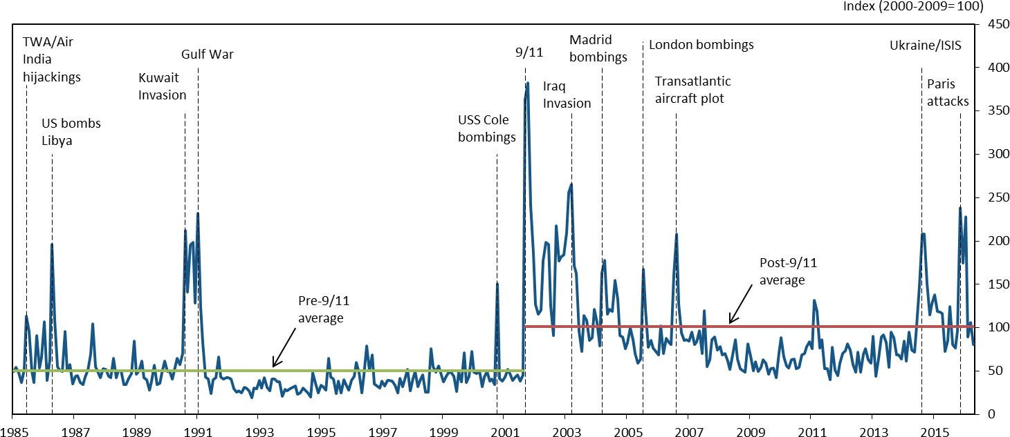

Source: Bank calculations and Caldara and Iacoviello (2016), *ibid*.

Less visible, but more fundamental drivers of economic uncertainty are the powerful forces arising from technology and globalisation. The integration of 40% of humanity into the global economy has re-orientated production, eliminated jobs and may have depressed wages. These dynamics have been accompanied by the implications of technology for the automation of jobs and of trade for their location; and the consequences of bigger, more global markets for ‘winner takes all’ patterns of compensation.

These secular trends can be reinforced by more cyclical moves (**Chart 2**).5 Cyclical economic uncertainty spiked during the crisis, remained very subdued until last autumn, and has since been on the rise.

The last of the uncertainty trinity is policy uncertainty.6 It is reduced when there are clear policy remits, frameworks, and institutional structures that empower and discipline fiscal, monetary and regulatory authorities. It is elevated when these are absent. And it is influenced by the effectiveness of the tools available to central banks, the clarity of their policy strategies and, crucially, the transparency of their communications.

5 A closely watched measure of economic uncertainty – the VIX – spiked when the global financial crisis hit. Measures that combine this with other sources of economic uncertainty, such as dispersion among forecasters’ growth projections, households’ unemployment expectations, and currency volatility, show clear variation over time, and rise at times of economic stress. See Haddow, A, Hare, C, Hooley, J and Shakir, T (2013) “Macroeconomic uncertainty: what is it, how can we measure it and why does it matter?”, Bank of England Quarterly Bulletin, Q2.

6 One way some of this has been measured is again to count occurrences in media articles of references to economics, uncertainty, and policy terms like “deficit”, “regulation” or terms relating to monetary policy. See: Baker, S, Bloom, N and Davis, S (2015), “Measuring economic policy uncertainty”, NBER Working Paper No. 21633, October.

# Chart 2: UK economic uncertainty spiked after the failure of Lehman Brothers

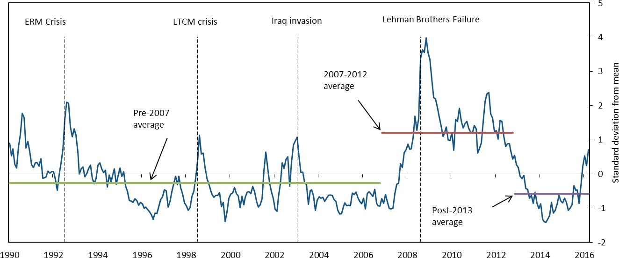

Source: Bank calculations and Haddow et al (*ibid.*). Shows data to end-May.

In recent years, policy uncertainty has increased globally. In some jurisdictions, fiscal frameworks have been questioned; in others, exchange rate regimes. And with very low interest rates and expanding unconventional policies, the efficacy of monetary policy itself has been questioned. The charge that central banks are out of monetary ammunition is wrong, but the widespread absence of global price pressures demands that our firepower be well aimed.

Indices of policy uncertainty are about 1¼ times their pre-crisis averages in the US and Japan, and as high as three times in China. In the UK, progress since the financial crisis has been more than totally unwound this year with the measure having risen to five times its pre-crisis average by the start of the official referendum campaign (**Chart 3**).

While clearly these three uncertainty measures are related, distinct movements are visible. The heady days of the Great Moderation were restrained by geopolitical uncertainty. During the financial and euro crises, by contrast, economic uncertainty dominated. And from 2012 onwards, with the abatement of the acute phase of the euro-area crisis, economic uncertainty began to fall back, only to be replaced by renewed geopolitical tensions and now sharply higher policy uncertainty (**Chart 4**).

# Chart 3: UK economic policy uncertainty has increased since the global financial crisis, rising sharply higher in early 2016

Source: Bank calculations and Baker et al, (2015), *ibid*.

# Chart 4: Three eras of uncertainty: geopolitical from 9/11 to 2008; economic uncertainty from 2008 to 2012; and policy uncertainty today.

Source: Bank calculations and authors cited in Charts 1-3 above. Economic policy and geopolitical uncertainty indices are de-meaned and shown relative to their respective standard deviations. Chart shows two-year centred moving average for each measure.

# What do the combined effects of uncertainty mean?

All this uncertainty has contributed to a form of *economic post-traumatic stress disorder* amongst households and businesses, as well as in financial markets – that is, a heightened sensitivity to downside tail risks, a growing caution about the future, and an aversion to assets or irreversible decisions that may be exposed to future ‘disaster risk’.7

There may be an *affect heuristic* at work. Put simply, long after the original trigger becomes remote, perceptions endure. They become embedded in economic narratives and their salience persistently affects risk perceptions and economic behaviour.

This point is not trivial. Research has shown that people who have experienced low returns throughout their lives, like the ‘Depression Babies’ of the 1930s, report lower willingness to take financial risk, are less likely to participate in the stock market, invest a lower fraction of their assets in equities, and are more pessimistic about future returns.8

Today, uncertainty has meant an inchoate sense of economic insecurity for many people despite generalised economic prosperity. Across the advanced economies, employment appears less secure, wages more subdued, and inequality more pronounced.

And its precautionary effects can mean spending is deferred because there is often a real option value to waiting.9 Firms delay investment decisions. Investors seek safe returns. Households put off buying durables. The common thread is that any economic decision that requires finance, has a sunk cost, or an uncertain payoff, is affected.

While the effect on output is clearly negative, the effect on inflation is ambiguous. Uncertainty’s stultifying effects weigh on employment and aggregate demand, creating disinflationary pressures, while the freeze in resource reallocation can hold back productivity and aggregate supply, creating inflationary pressures.10 11 Higher uncertainty can also mean investment responds more sluggishly to demand stimulus.12

7 See Broadbent (2014) for a further discussion of disaster risk and what it means for safe rates. Broadbent, B (2014), “Monetary policy, asset prices and distribution”, Bank of England. See also Barro, R (2009), “Rare disasters, asset prices, and welfare costs”, American Economic Review, 99(1).

8 Malmandier and Nagel (2011): “Depression Babies: do macroeconomic experiences affect risk taking?”, Quarterly Journal of Economics.

9 See Bernanke, B (1983), “Irreversibility, uncertainty and cyclical investment”, Quarterly Journal of Economics, 98(1).

10 Bloom (2009) shows how economic uncertainty reduces the shrinkage of low productivity firms and the expansion of high productivity firms, reducing the reallocation of resources towards more productive units. Leduc and Liu (2012), emphasise the aggregate demand

effects empirically for the US. Leduc and Liu (2012), “Uncertainty shocks are aggregate demand shocks”, Federal Reserve Bank of San Francisco Staff Paper 2012-10.

11 Together with the aggregate effects, higher stock market volatility generates greater dispersion in firms’ profit growth and industries’ productivity growth. Bloom, N (2009), “The impact of uncertainty shocks”, Econometrica, 77(3), May.

12 Bloom, N, Bond, S and Van Reenen, J (2007), “Uncertainty and investment dynamics”, Review of Economic Studies, 74.

# Chart 6: Serial optimism on earnings

(a) FTSE All-share (b) S&P 500

2012 2013 2014

2015 2016E 2017E 2018E

2012 2013 2014

2015 2016E 2017E

EPS

2018E

360

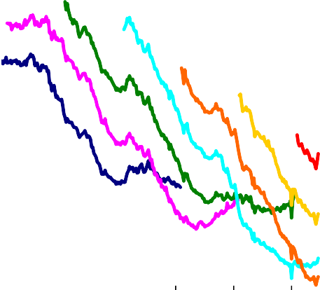

EPS

160

150

320

140

280 130

120

240

110

2011 2012 2013 2014 2015 2016

(c) Eurostoxx

2012 2013

2014 2015

2016E 2017E

2018E

200

EPS

32

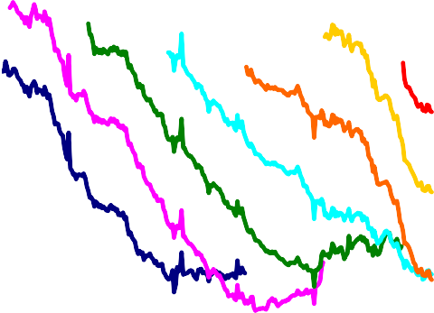

2011 2012 2013 2014 2015 2016

100

30

28

26

24

22

20

2011 2012 2013 2014 2015 2016

Source: Datastream. Charts show different vintages of earnings per share (EPS) forecasts for major equity indices, by year.

We have seen the consequences of these effects in financial markets for some time. How are these dynamics manifest today?

First, there has been serial disappointment in corporate earnings (**Chart 6**). The failure of past relationships to reassert, especially rates of productivity growth, has embedded a growing sense of uncertainty in markets about the fundamentals upon which future prosperity will be built.

Second, the equity risk premium has risen sharply (**Charts 7** and **8**). Low earnings growth can account for some of this.13 But so does higher risk aversion as investors seek the safety of bonds partly as a hedge against extremes.

# Chart 7: Earnings yield on equities and 10-year government bonds yields have diverged since 2000

**Chart 8: UK equity risk premium is estimated to have grown since 2000, and together with lower growth expectations, explains bulk of**

**equity-bond spread currently**

Per cent

18

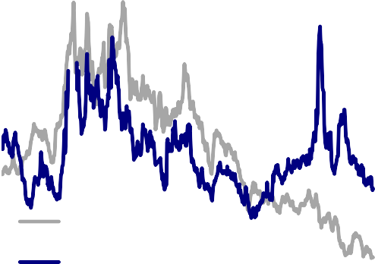

10-year government bond yield

Earnings yield

16

14

12

10

8

6

4

2

0

1965 1975 1985 1995 2005 2015

Source: Thomson Reuters Datastream and Bank Calculations. Shows FTSE All-Share equity yield and UK 10- year government bond yield.

Percentage points

12

Unexplained component

ERP contribution

Growth contribution

Equity-bond yield spread

2000

2005

2010

2015

10

8

6

4

2

0

-2

Source: IMF, Bloomberg, Thomson Reuters Datastream and Bank calculations. The equity-bond yield spread is the difference between the reciprocal of the FTSE All-Share

price-earnings ratio and the UK 10-year government bond yield. The growth contribution is calibrated from the IMF 5-year-ahead world growth and inflation forecasts. The ERP contribution is calibrated using the VAR model described in Chin and Polk (2015), ‘A forecast evaluation of expected equity return measures’, Bank of England Working Paper, No. 520.

The serial disappointment in earnings growth is mirrored in global growth since the crisis (**Chart 9**). In advanced economies, uncertainty appears to be holding back spending, particularly by corporates. Globally, investment remains weak (**Charts 10** and **11**). In the UK, relatively strong business investment growth in the past few years has only restored it to a level still shy of its pre-crisis share of GDP (**Chart 12**), and it is tracking below past cycles (**Chart 13**).

13 A fall in expected growth rates will tend to push down on expected future earnings, lowering equity prices and increasing the equity yield. At the same time, a fall in growth expectations will tend to be reflected in a lower expected path of risk-free rates, pushing down on bond yields. So a decline in growth expectations will tend to widen the spread between equity and bond yields. Since equity prices depend on earnings expectations at all future horizons, the equity yield (and hence the equity-bond yield spread) will be particularly sensitive to expectations about growth rates at long horizons

# Chart 9: Consistent downward revisions to GDP growth forecasts

Actual GDP growth 2011

2012 2013

2014 2015

2016 2016 Per cent

8.0

Dotted lines = Emerging economies Solid lines = Advanced economies

6.0

4.0

2.0

0.0

2010 2011 2012 2013 2014 2015 2016

Source: IMF World Economic Outlook. Each line shows how forecasts for a particular calendar year have evolved over time. The diamond shows the eventual outturn.

# Chart 10: whole economy real investment substantially weaker than pre-crisis forecasts

**Chart 11: Advanced economy investment has fallen relative to GDP, remains lower than past episodes**

1980 1989

Residual

Non-residential Total

Equipment Residential

Per cent

10

0

-1

-2

-3

-4

-5

-6

2001 2007

0

0

0

0

0

0

Spain

Italy Denmark France

US

Canada

UK

Germany

Switzerland

Sweden

pp fall in investment

share of GDP

1.0

0.5

0.0

-0.5

-1.0

-1.5

-2.0

-2.5

-3.0

-3.5

-4.0

-4.5

T T+1 T+2 T+3 T+4 T+5 T+6 T+7 T+8

Years

Source: IMF World Economic Outlook and Bank calculations.

Source: IMF World Economic Outlook and Bank calculations.

# Chart 12: UK business investment still short of pre-crisis share of GDP…

12

Real

Nominal

11.5

11

10.5

Per cent of GDP

10

9.5

9

8.5

8

2001Q1

2002Q2

2003Q3

2004Q4

2006Q1

2007Q2

2008Q3

2009Q4

2011Q1

2012Q2

2013Q3

2014Q4

2016Q1

# Chart 13: … and tracking below past cycle average

Business investment, peak GDP = 100

130

Average of past cycles

2008

120

110

100

90

80

70

60

-8 -6 -4 -2 0 2 4 6 8 10 12 14 16 18 20

Quarters since GDP peak

Source: ONS and Bank calculations. Source: ONS and Bank calculations.

The Monetary Policy Committee’s May forecast incorporates some of these uncertainty effects. Our projection for the global economy was for 2016 growth of just 3%, the slowest pace since 2009.

Domestically, we expected growth to slow to 2% in 2016, partly as a consequence of an increasing drag from uncertainty.

Specifically, in May the Monetary Policy Committee (MPC) estimated that the pick-up in UK economic uncertainty it had recently seen would lower our GDP by around 0.7% after a year. While material, this was less than suggested by past relationships partly because our projections were conditioned, by convention, on a vote to remain in the EU, suggesting uncertainty would fade smartly after the referendum.

Even before 23rd June, we observed the growing influence of uncertainty on major economic decisions. Commercial real estate transactions had been cut in half since their peak last year. Residential real estate activity had slowed sharply. Car purchases had gone into reverse. And business investment had fallen for the past two quarters measured. Given otherwise accommodative financial conditions and a solid domestic outlook, it appeared likely that uncertainty related to the referendum played an important role in this deceleration.

It now seems plausible that uncertainty could remain elevated for some time, with a more persistent drag on activity than we had previously projected. Moreover, its effects will be reinforced by tighter financial conditions and possible negative spill-overs to growth in the UK’s major trading partners.

In sum, the material slowing in growth that the MPC had identified as a risk associated with the referendum now looks likely to be our central forecast. Using reports from our nationwide network of agents, private

survey evidence, and hard data, in the coming weeks we will estimate the extent of the deceleration as we formulate our August projections.

# Policies in an uncertain world

When uncertainty is high, policymakers should have three objectives. First, conduct a sober, objective assessment of the outlook and the risks to it. Second, develop and communicate a plan to reduce those risks and to seize new opportunities. And third, do no harm, by minimising any possible confusion about the commitment to core macroeconomic policy frameworks themselves.

In Tim Geithner’s famous dictum, “plan beats no plan.” And in my experience, a plan that is clearly articulated and transparently executed is best of all.

A plan for the UK’s current challenges would include a comprehensive strategy for engaging with the EU and the rest of the world – including clarifying the UK’s future trading arrangements, calibrating its openness to migration, ensuring the continuity of capital flows, and confirming the appropriate regulatory framework for the UK financial system.

The impact of concrete progress towards these objectives would be amplified by an overarching, positive and animating narrative for growth in a post-Brexit world. To emerge from an uncertain world with confidence, people and businesses need a fixed point by which to navigate. Once identified, everyone can then play a role supporting the strategy to get us to our destination.

That strategy must be grounded in the bedrock of the UK’s existing macro policy institutions and frameworks. That means fiscal policy anchored in a clear commitment to long-run sustainability and buttressed by the independent Office for Budget Responsibility.

And it means respecting the frameworks for the other major arms of macroeconomic policy as they are set out in statute and conducted by the Bank of England. The Bank has clear remits and can deploy a wide range of instruments. With its goals defined by Parliament, the Bank has operational independence. Its policy strategies and communications are decided by independent, expert committees whose members are individually accountable to Parliament for their analysis and policy actions.

The Bank conducts policy consistently, transparently and accountably. Its policy committees are straight with the British public about the risks and trade-offs in the pursuit of our objectives.

This institutional framework is critical to reduce uncertainty and essential to promote prosperity.

With this backdrop, let me now describe the concrete steps the Bank has taken to address uncertainty and how we can be expected to act in the weeks and months ahead.

* 1. *Financial policy*

Let me begin with financial policy. The Bank of England realised long ago that banks had been woefully undercapitalised in the run-up to the crisis and needed to build significant resources in order to serve the real economy in a risky and uncertain world.

The reforms have been enormous, with the capital requirements of our largest banks now ten times higher than before the crisis.

Moreover, the Bank has stress tested our major banks and building societies against scenarios far more severe than the country currently faces. In fact, our 2015 stress test entailed losses twice those experienced during the financial crisis*.*

At its last meeting in March, the Financial Policy Committee (FPC) “assessed the risks around the referendum [were] the most significant near-term domestic risks to financial stability.” 14

Because we took the risks seriously in advance, the Bank could draw upon its supervisory expertise, its market operations, and its macroeconomic analysis to put in place a range of effective contingency plans. These measures reinforce the significant steps we have taken over the past several years to enhance the resilience of the financial system.

As a result of all these actions, UK banks have raised over £130bn of capital, and now have more than

£600bn of high quality liquid assets.

And as a backstop, in order to support market functioning, the Bank of England continues to stand ready to provide more than £250bn of additional funds through its normal facilities.

As a further precaution, reflecting the possibility that heightened uncertainty may last a while longer, today the Bank of England is announcing that it will continue to offer Indexed Long-Term Repo operations on a weekly basis until end-September 2016. This will provide additional flexibility in the Bank’s provision of liquidity insurance over the coming months.

These facilities provide an effective way for banks to manage their liquidity, with a competitive auction process, designed to encourage usage, but where at times some bids will go unfilled.

14 The Record of this meeting is available at: <http://www.bankofengland.co.uk/publications/Documents/records/fpc/pdf/2016/record1604.pdf>

We expect institutions to draw on this funding if and when appropriate, just as we expect them to draw on their own resources as needed in order to provide credit, support markets, and generally supply financial services to the real economy.

In order to have confidence and plan for the future, financial institutions, like the rest of us, desire certainty. That is why the Bank will continue to be very clear about their regulatory framework. Our liquidity framework is now established and effective. Over the past year, the FPC has finalised the overall capital framework.

We are steadily implementing measures to develop ring-fenced banks and to end the scourge of too-big-to-fail.

Nothing in financial regulation has changed as a result of last week’s referendum. It will not change until the process of the UK’s withdrawal from the European Union is complete, until the UK is no longer a member of the EU and until EU law ceases to have effect in the UK. The law is the law. Rules are rules. The Bank is continuing to implement the current regulatory framework until any new arrangements with the EU take effect.

By enhancing the resilience of banks and by providing regulatory certainty so that firms can operate and plan with confidence, the Bank of England is ensuring that the financial system can continue to provide credit to businesses and households. This progress means that the financial system will dampen the aftershocks from recent events rather than amplify them.

Next Tuesday, the independent FPC will release its biannual assessment of risks in its *Financial Stability Report*, and it will take any further actions it deems appropriate to support financial stability. Consistent with public accountability, we will then take questions from the media that day and will testify before Parliament the following week.

* 1. *Monetary policy*

Let me now turn to monetary policy. In May, the Monetary Policy Committee set out its central outlook for steady growth accompanied by a gradual return of inflation to the target.

As required by our remit, the MPC identified that the most significant risks to its forecast concerned the referendum.15 This was the view of all nine independent members of the MPC.

In May, the MPC judged that a sustainable return of inflation to the 2% target probably required a gradually rising path for Bank Rate over the next three years as growth picked up, jobs and wages increased and the drags from a stronger currency and lower commodity prices faded.

15 Copies of the minutes are available at: <http://www.bankofengland.co.uk/publications/minutes/Pages/mpc/default.aspx>

As required by its remit, the MPC has already described how a vote to leave the EU could materially alter the outlook for growth and inflation.

As a result of increased uncertainty and tighter financial conditions, UK households could defer consumption and firms delay investment, lowering labour demand and causing unemployment to rise. Through financial market and confidence channels, there are also risks of adverse spillovers to the global economy.

At the same time, supply growth is likely to be lower over the next three years, reflecting slower capital accumulation and the need to reallocate resources across sectors of the economy. Both of these forces may be exacerbated by higher uncertainty and tighter financial conditions.

Finally, as expected, sterling has depreciated sharply. For given foreign demand, this will mean support to net trade, though this may well be dampened by uncertainty around future trading relationships. A lower exchange rate will also entail higher prices for imported consumer goods, energy and capital goods, and consequently lower real incomes.

As the MPC said prior to the referendum, the combination of these influences on demand, supply and the exchange rate could lead to a materially lower path for growth and a notably higher path for inflation than set out in the May *Inflation Report*. In such circumstances, the MPC will face a trade-off between stabilising inflation on the one hand and avoiding undue volatility in output and employment on the other. The implications for monetary policy will depend on the relative magnitudes of these effects.

In my view, and I am not pre-judging the views of the other independent MPC members, the economic outlook has deteriorated and some monetary policy easing will likely be required over the summer.

The Committee will make an initial assessment on 14 July, and a full assessment complete with a new forecast will follow in the August *Inflation Report*. In August, we will also discuss further the range of instruments at our disposal.

These judgments will benefit from the Bank’s joined-up approach. For example, the PRA’s direct line of sight of banks, building societies and insurers, and the FPC’s oversight of systemic risks, allows the Bank to understand better the net impact of any monetary actions on financial conditions, and ultimately businesses and households. As we have seen elsewhere, if interest rates are too low (or negative), the hit to bank profitability could perversely reduce credit availability or even increase its overall price.

There are also interactions between prudential rules and the provision of credit in the face of large macro uncertainty. The Bank of England is well positioned to understand these interactions and will work across its policy committees to maximise the coherence and effectiveness of their efforts.

I can assure you that in the coming months the Bank can be expected to take whatever action is needed to support growth subject to inflation being projected to return to the target over an appropriate horizon, and inflation expectations remaining well anchored.

# Conclusion

Above the central arch of this Court Room is a weather vane. Originally installed in 1805, it played a central role in the Bank’s management of a different type of uncertainty – meteorological. When the wind blew from the east, ships would be able to travel up the Thames, meaning London’s merchants would need credit to purchase the cargo. When it blew from the west, credit would need to be withdrawn. This Regency forecasting model helped the Bank of England to provide an anchor of stability.

Today, while the economy is more complex and our models less reliable, the Bank has identified the clouds on the horizon and can see that the wind has now changed direction.

Over the past few months, working closely with the Chancellor and with HM Treasury, we put in place contingency plans for the initial market shocks. They are working well.

Over the coming weeks, the Bank will consider a host of other measures and policies to promote monetary and financial stability.

In short, the Bank of England has a plan to achieve our objectives, and by doing so support growth, jobs and wages during a time of considerable uncertainty.

Part of that plan is ruthless truth telling. And one uncomfortable truth is that there are limits to what the Bank of England can do.

In particular, monetary policy cannot immediately or fully offset the economic implications of a large, negative shock. The future potential of this economy and its implications for jobs, real wages and wealth are not the gifts of monetary policymakers.

These will be driven by much bigger decisions; by bigger plans that are being formulated by others. However, we will relentlessly pursue monetary and financial stability. And by doing so we will facilitate the adjustments needed to realise this economy’s full potential.